New Functionality – Sync Reports for Respective Department Forms
Step 1: Login through your respective State Admin ID
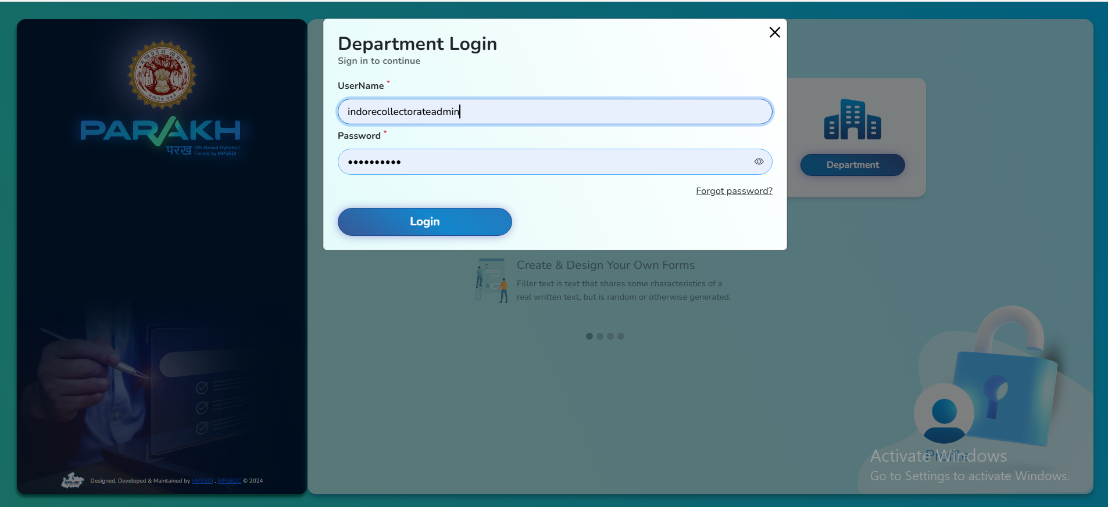

Step 2: On Dashboard Screen, Click on “Tabular View of Inspection” then Click on “Sync Data”.
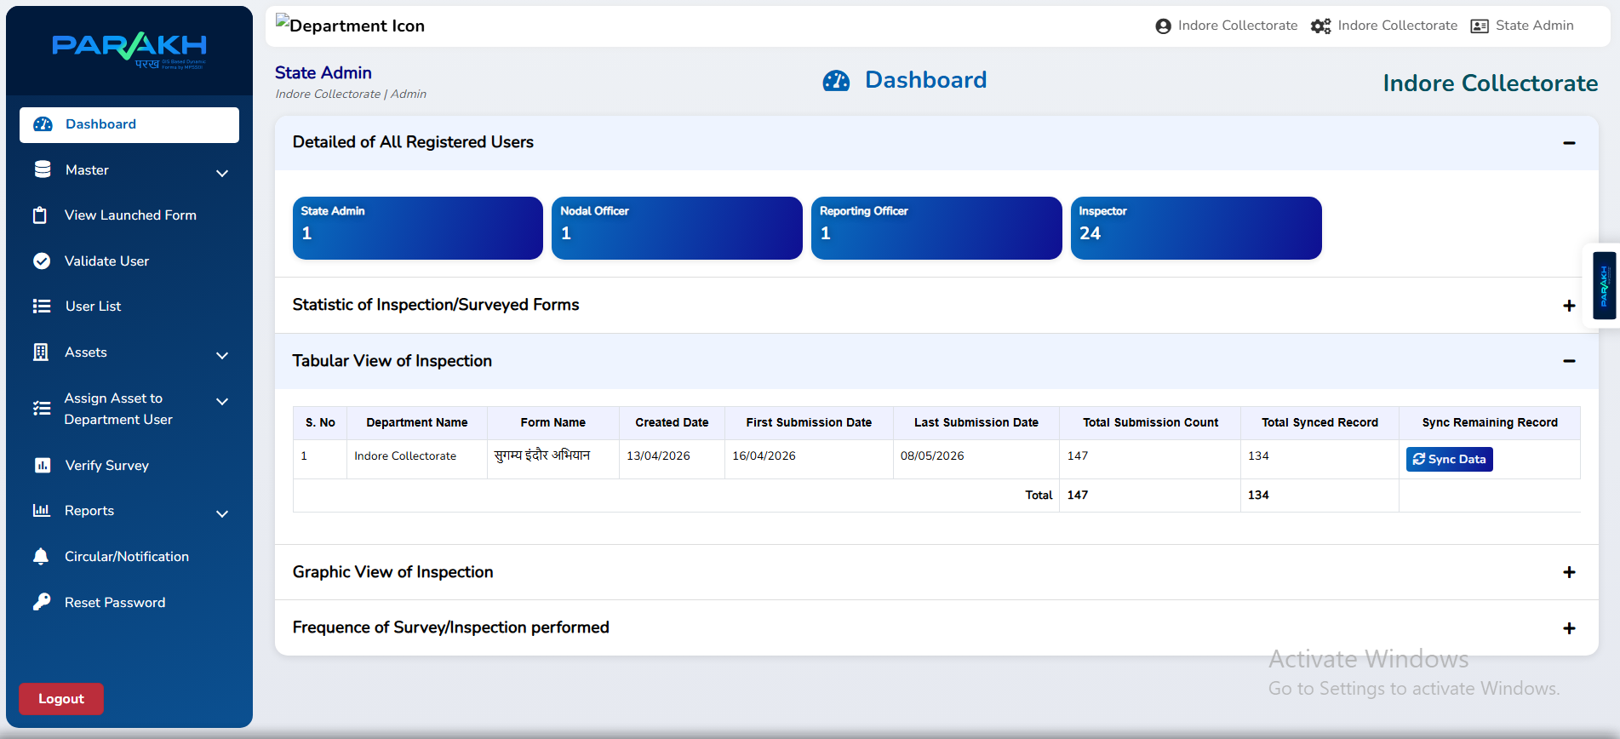
Finally, Data is Synced.
